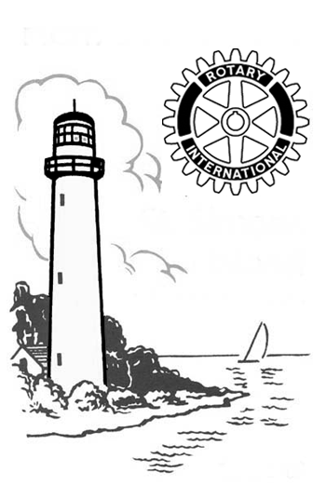
Rotary Club
St. Simons Island
Georgia, U.S.A

District 6920

Rotary Spray

June 17, 2008
Today’s Program:

Classification Talks

Rotary Club
St. Simons Island
Georgia, U.S.A

District 6920

Area Rotary Clubs
Club Meeting Day & Time
Brunswick Christie’s Restaurant Thu. 12:45 P.M.
Glynn County Christie’s Restaurant Wed. 7:30 A.M.
Jekyll Island Jekyll Island Club Hotel Wed. 7:30 A.M.
St. Simons Island Sea Palms (Confirm before attending) Tue. 1:00 P.M.
SSI Marshes of Glynn Epworth—Jinks Dining Room Thu. 7:30 A.M.

Managing Editor & Publisher
Bill Warren
bwarren33@comcast.net
Data Reports
Becky Stephenson
Guests – Hosts
Don Robertson – Jim Bruce
Mimi Rogers – Merry Tipton
John Ferguson – Allen Berry
Attendance
June 10 – 55 members (57%)
Rotobucks
Marie Dodd - $39
Makeups
Ruth Heyward – Online

Greeters
6/17 Leon Jorgensen, Erik
Kaufmann
6/24 Teresa Jones-King, Calder
Kinney

Birthdays: June 17 – 24
John Law – 6/18

Club Notes

New Members Bring Club Total to 130: Two new members, Don Robertson (a former member returning to the club) and Linda Muir, were approved June 10, bringing club membership to 130, an increase of 7 from the beginning of the club year on July 1, 2007. This total well exceeds the District goal of a 1% increase. We lost 10 active members, while gaining 16 active members and 1 honorary member. The current membership total is 124 active and 6 honorary. (Report from Brooke Pridmore, Club Service & Membership Director.)
___________________________________________________

Upcoming Programs

6/24 - Outgoing President’s Final Report – Installation
of New Officers & Directors
7/1 - “Angel Financing” – Bob Franklin – Chairman,
Ariel Savannah Angel Partners
7/8 - County Commission Candidate Forum
7/22 - District Governor Kenan Kern
7/29 - Club Assembly – Incoming President’s Report
and Goals

June 10, 2008
Sudy Leavy
Author, Storyteller
Sudy Vance Leavy spoke about the subject of her new book on Hofwyl-Broadfield Plantation, which was home to five generations of one family.
Located where the Altamaha River empties into the Atlantic Ocean near Brunswick, Hofwyl-Broadfield was the last of the coastal plantations to grow rice. It was this legacy that Ophelia Dent bequeathed to the State of Georgia at her death in 1973.
The historic site is operated by the Georgia Department of Natural Resources, Parks and Historic Sites Division.
Sudy Leavy lives in Darien. She holds a master’s degree in English from Georgia Southern University.
She has been an English teacher at Glynn Academy, and an adjunct professor at what was Brunswick Junior College, and later at Coastal Community College.
Sudy has three children and a number of grandchildren. She has become devoted to Georgia history, and in particular, coastal Georgia history.
(The program was introduced by Gary Schwartz.)
__________________________________________________

Path Planned for Bicyclists, Hikers on North End
Club member Russ Marane, president of the St. Simons Land Trust, reported that work is expected to begin this summer on an eight-foot-wide, concrete path that – when completed – will stretch from the Sea Island stables along the west side of Lawrence Road to near the entrance of Hampton Plantation.
The first stage of this path for hikers and bicyclists is made
possible by a $500,000 anonymous donation to the Path Foundation, which has created 125 miles of pathways in Metropolitan Atlanta and the Silver Comet Trail connecting Atlanta to Aniston, AL.
Marane said the county has allocated another $250,000 for the project, and the Land Trust will raise $750,000 for the total project cost of $1.5 million. Marane said the new path, which he hopes will be completed by the end of this year, will “set the standard for new and upgraded trails” on the island.


Rotary Officers & Directors

International President
District 6920 Governor
District 6920 Governor Elect
District 6920 Governor Designee
Assistant Governor - SSI Area

Wilfred J. Wilkinson
Dick Hyer
Kenan Kern
Clyde Taylor
Pat Storino
St. Simons Island Rotary Club

President
President Elect
Secretary
Assistant Secretary
Treasurer
Financial Administrator
Immediate Past President
Past Presidents’ Representative
Sergeant-at-Arms
Assistant Sergeant-at-Arms
Historians
Jim Bruce
Chuck Cansler
Maria Vogt
Becky Stephenson
Linda Butler
Shirley Redanz
Pat Storino
Kevin Lokey
Jack McDonald
Mike Harris
Allen J. Berry & Julian Flexer
Directors

Club Relations & Public Relations
Club Service & Membership
Community Service
International Service
Programs & Fellowship
Vocational Service
Stan Kyker
Brooke Pridmore
Millard Allen
Stan Humphries
Don Fielder
Robert Cable

The Four-Way Test
of the things we think, say or do
1. Is it the truth?
2. Is it fair to all concerned?
3. Will it build goodwill and better friendships?
4. Will it be beneficial to all concerned?
On-Line Makeup • www.rotarydistrict6920.net

Rotary Club of St. Simons • Founded in 1950 – www.ssirotary.org
Meets Tuesday 1 P.M. - Sea Palms Golf & Tennis Resort
Rotary Club of St. Simons • P.O. Box 21887 • St. Simons Island, GA 31522
www.rotarydistrict6920.net • www.rotary.org for Rotary International

